**University Of Engineering and Technology, Lahore**

**Computer Engineering Department**

1

| **Installation of SQL Server**  • Download and Install MS SQL Server 2019 Express edition from https://www.microsoft.com/en us/sql-server/sql-server-downloads  • Install the latest version of SQL Server Management Studio from Download SQL Server Management Studio (SSMS) - SQL Server Management Studio (SSMS) | Microsoft Docs  • Instance of SQL Server should support both Windows based authentication and SQL Server Authentication.  **Create a New Database**  • Create a new database named Northwind. The steps are as follows  ▪ Step 1  Open Microsoft SQL server management studio and connect it with the SQL server using Window based authentication as shown below    *Figure 1*  ▪ Step 2 |
| --- |

2

**University Of Engineering and Technology, Lahore**

**Computer Engineering Department**

| Right click on Databases and click on ‘New Database’    *Figure 2*  ▪ Step 3  Choose a database name such as ‘Northwind’ and click ‘OK’ |
| --- |

3

**University Of Engineering and Technology, Lahore**

**Computer Engineering Department**

| *Figure 3*  • Restore Schema using scripts northwind.sql available at  https://drive.google.com/file/d/1V66pnAgWgJo6Y76XwkTTWrq0KdZGp-x9/view?usp=sharing. The steps are as follows  ▪ Step 1  Download the script from the above mentioned link  ▪ Step 2  Right click on the Northwind database and select New Query |
| --- |

4

**University Of Engineering and Technology, Lahore**

**Computer Engineering Department**

| *Figure 4*  ▪ Step 3  Open the downloaded northwind.sql script in any editor (say Notepad) and copy the script in the newly created query window  *Figure 5*  ▪ Step 4  Execute the script by clicking on ‘Execute’ button |
| --- |

5

**University Of Engineering and Technology, Lahore**

**Computer Engineering Department**

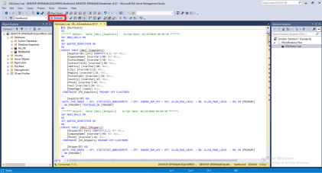

*Figure 6*

• Restore schema data using northwind_data.sql available at

https://drive.google.com/file/d/1wS9soGuKHe0LNrYZiiroXQHusJzGTCCf/view?usp=sharing. The steps are as follows

▪ Step 1

Download the script from the above mentioned link

▪ Step 2

Right click on the Northwind database and select New Query

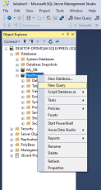

*Figure 7*

▪ Step 3

Open the downloaded northwind_ data.sql script in any editor (say Notepad) and copy the script in the newly created query window

6

**University Of Engineering and Technology, Lahore**

**Computer Engineering Department**

| *Figure 8*  ▪ Step 4  Execute the script by clicking on ‘Execute’ button  *Figure 9*  **Generate Scripts of a schema**  • Step 1  Right click on your database and select Task -> generate script. |
| --- |

7

**University Of Engineering and Technology, Lahore Computer Engineering Department**

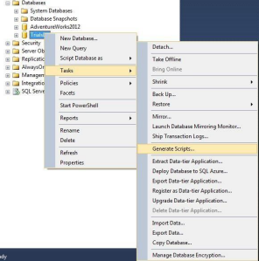

*Figure 10*

**Figure 1 Database_Scripts_With_Data_Select_Option**

• Step 2

Click next in the introduction screen

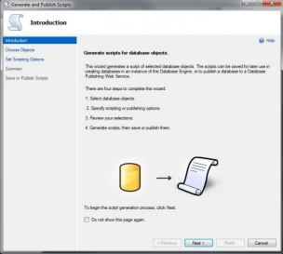

*Figure 11* ***Database_Scripts_With_Data_Introduction***

8

**University Of Engineering and Technology, Lahore Computer Engineering Department**

• Step 3

Select the database object which you are all you need and then click next.

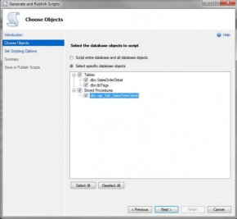

*Figure 12*

• Step 4

Now you will be shown a window which asks you about how your script should be published. 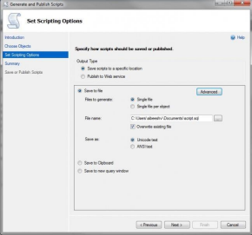

*Figure 13* ***Database_Scripts_With_Data_Publish_Options***

Click advanced in that window.

• Step 5

9

**University Of Engineering and Technology, Lahore Computer Engineering Department**

Select ‘Schema and data’ from type of data to script option and then click OK. 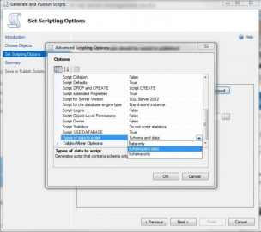

*Figure 14* ***Database_Scripts_With_Data_Advanced***

Click next.

• Step 6

Click finish, now check the script file, it must be having the insert queries too. 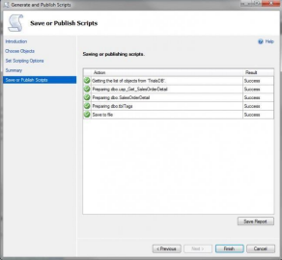

*Figure 15* ***Database_Scripts_With_Data_Finish***

10

**University Of Engineering and Technology, Lahore Computer Engineering Department**

Now what else is pending, go ahead and run your script.

**Task 1**

1. Create a new database named TestDB_2021_CE_X

2. Create a new table named student using some attributes

3. Generate Scripts of your database

4. Restore your schema to another machine

5. Generate scripts of data

6. Restore data to other system as well

**Task 2**

∙ Google Cloud Platform (GCP) provides the cloud services for writing queries. Create an account on GCP big query. The steps are as follows

▪ Step 1

Go to the link Google Cloud Platform to create an account on GCP bigquery

▪ Step 2

Click on ‘Select a project’ button

*Figure 16*

▪ Step 3

Create New Project

*Figure 17*

▪ Step 4

Now again click on “Select a project” to choose the created project to work with

11

**University Of Engineering and Technology, Lahore**

**Computer Engineering Department**

| *Figure 18*  ▪ Step 5  Select the created project from the project’s list    *Figure 19*  ▪ Step 6  Click on BigQuery resource |
| --- |

12

**University Of Engineering and Technology, Lahore**

**Computer Engineering Department**

| *Figure 20*  ▪ Step 7  You may read the available BigQuery guide or click on Done  *Figure 21*  ▪ Step 8  Here is the workspace overview where you will explore about BigQuery |
| --- |

13

**University Of Engineering and Technology, Lahore**

**Computer Engineering Department**

| *Figure 22*  ∙ Explore Bigquery sandbox.  ∙ Explore public datasets  ∙ Explore Github dataset |
| --- |
| **Homework Questions:**  ∙ Write your understanding related to Bigquery and Github dataset in the file GCP_2021_CE_X.docx and submit on google classroom.  ∙ Explore one additional tool for database models, run it on your machine and write your learning experience in a document named as DBtool_2021_CE_X.docx format. |
| **Submission Instructions:**  ∙ Submit your homework in .docx files format by Sunday, 10th September, 2023 9 P.M. |

14